Module Name: Login Module with identifying Bug And report it
Test Case ID: st_01
Webpage URL: https://www.instagram.com/

Step 1 : Open Login Page
Step 2 : Enter Username and Password
Step 3 : Enter wrong Password
Step 4 : Leave Username and password blank
Step 5: There Is a bug Username can also be wrong but it only shows Password is incorrect
Step 2:
Step 1:

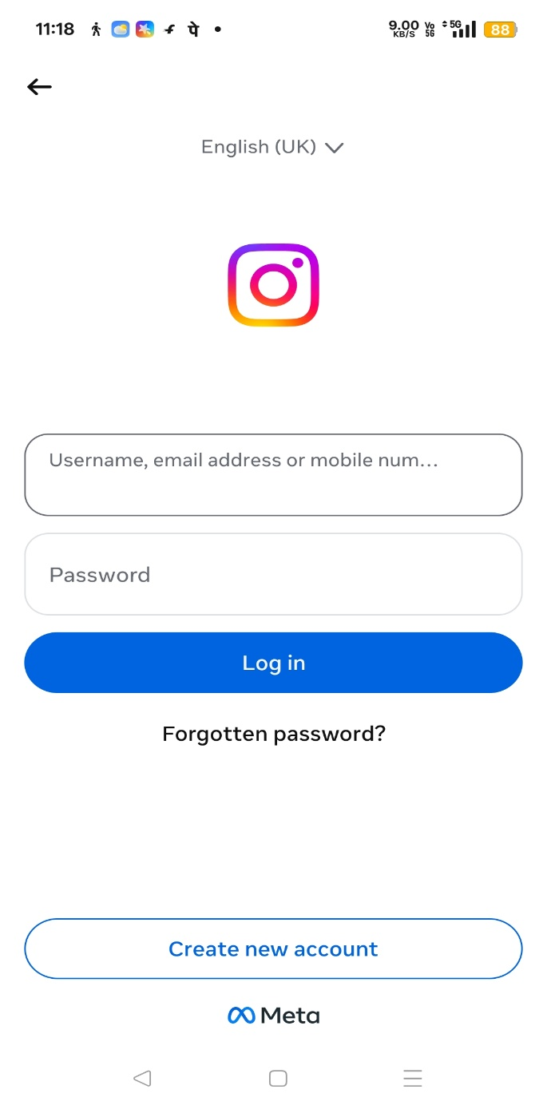
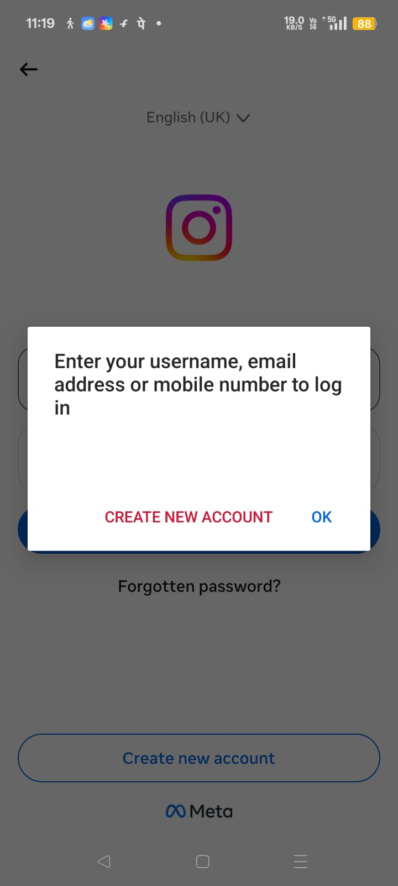

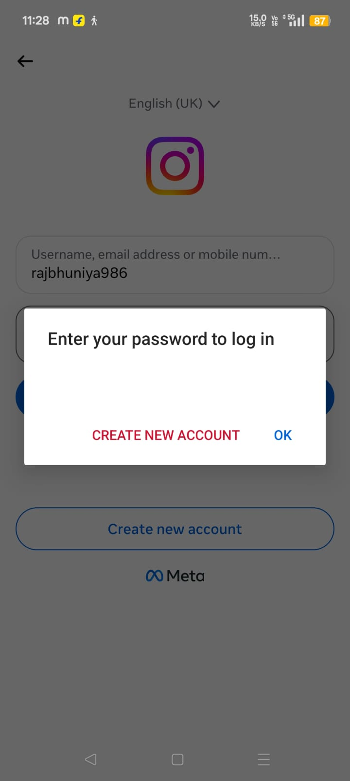
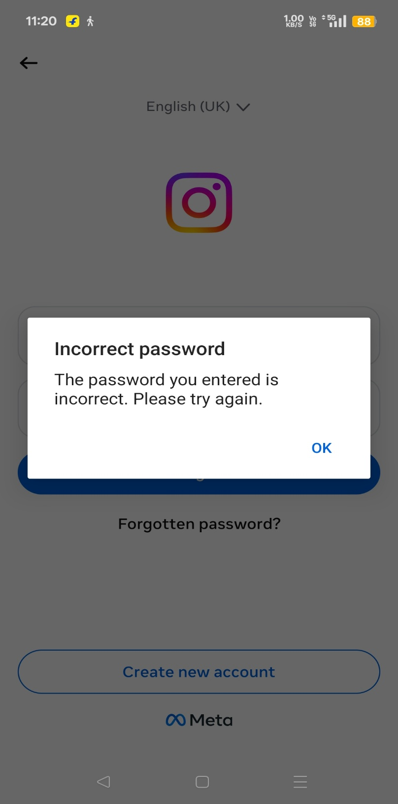
Step 4 :

Step 3 :

